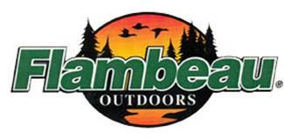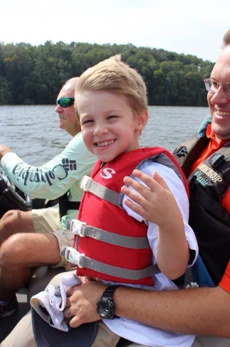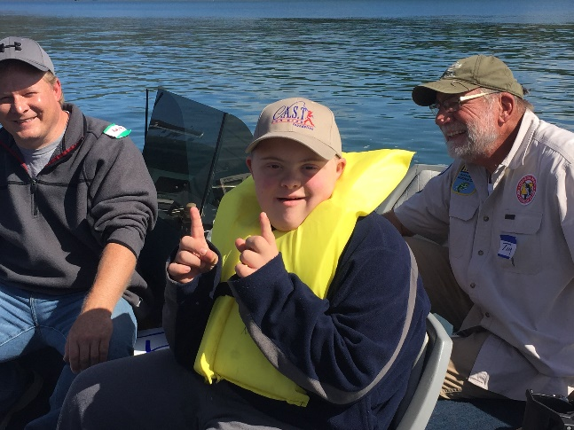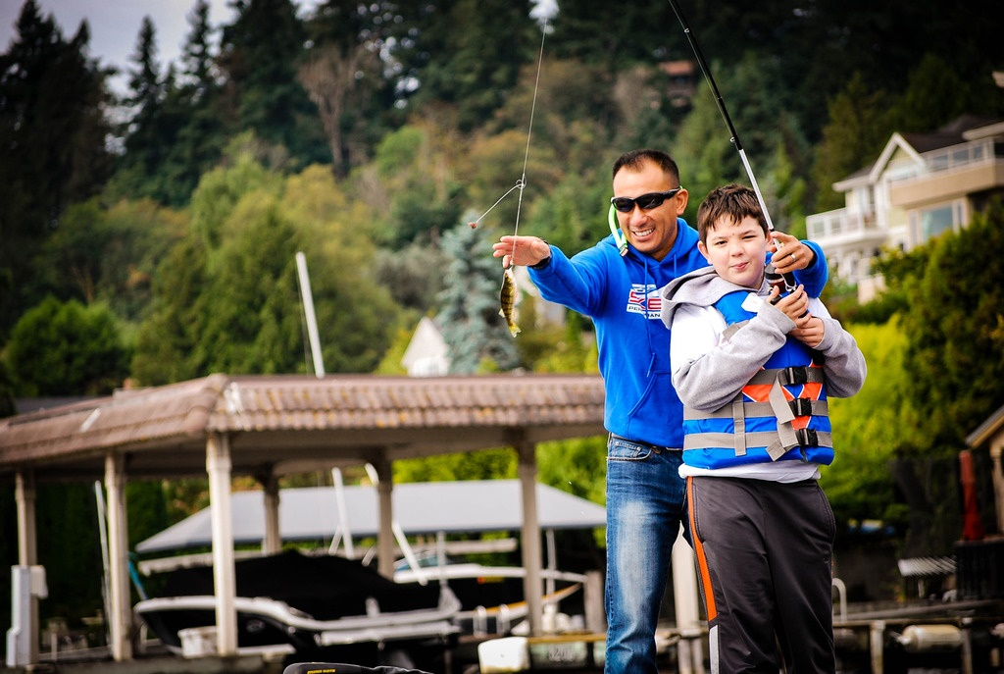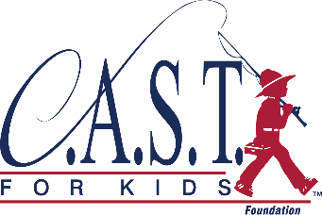

**www.castforkids.org**

Volunteer with C.A.S.T. for Kids today!

VOLUNTEERS help us make a **SPLASH**

O’Neill Forebay C.A.S.T. for Kids

Saturday, September 22, 2018 | 8:30 AM - 1:00 PM

***Volunteers should arrive at 7:30 AM***

We believe every child is worth celebrating, can overcome limitations, and have a victorious day!.

* BOATERS needed!  
  **40 experienced anglers with a boat** to take one child plus a parent or guardian, show them proper fishing techniques, and to help them land their first catch!
* On-Shore Volunteers  
  15 volunteers needed to assist with all aspects of event setup and facilitation

**PRE-REGISTRATION REQUIRED at castforkids.org/event/oneillforebay**

If you have questions, please contact:  
Joe Tapia  
joseph.tapia@water.ca.gov  
(559) 907-4418

September 22, 2018