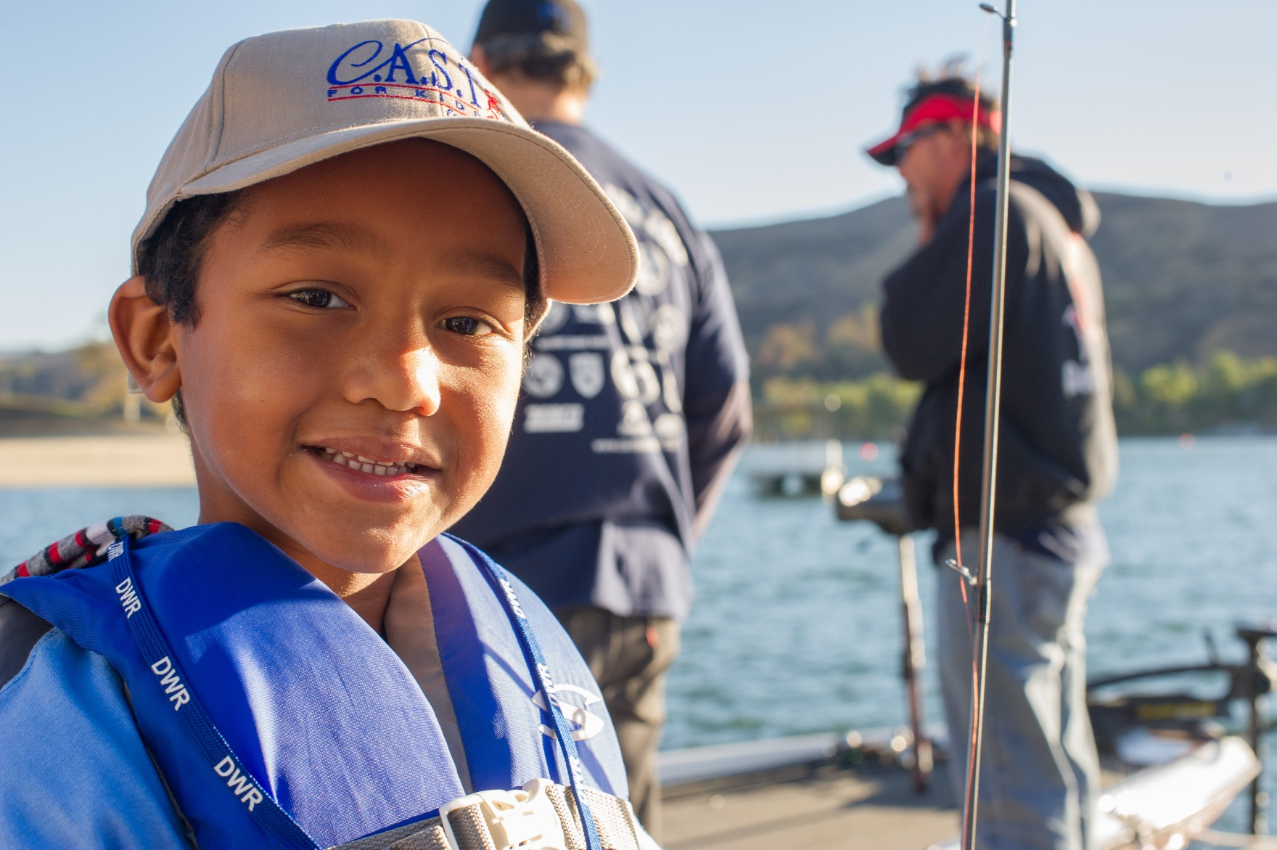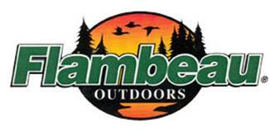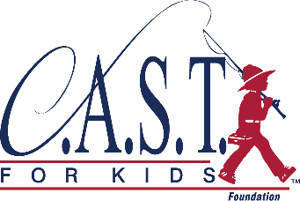A group of people riding on the back of a bicycle

Description generated with very high confidence

* FREE Fishing GEAR FUN-PACK!  
  Includes rod & reel, tackle box, event t-shrit, cap, and photo plaque!
* WHO?  
  Participantsmust pre-register and should be 6-18 years of age.
* REGISTRATION  
  **Pre-registration required at castforkids.org/event/oneillforebay**
* If you have questions, please contact:  
  Joe Tapia  
  (559) 907-4418

**www.castforkids.org**

Join C.A.S.T. for Kids

for a free fishing event for kids with special needs!

A joyful day of fishing and boating brings kids with special needs, their families, and community volunteers together for an explosion of fun and inspiration.

Register now!

O’Neill Forebay C.A.S.T. for Kids

Saturday, September 22, 2018 | 8:00 AM - 1:00 PM

*Space is limited—sign up today!*

Make a **SPLASH**

We believe every child is worth celebrating, can overcome limitations, and have a victorious day!.

September 22, 2018