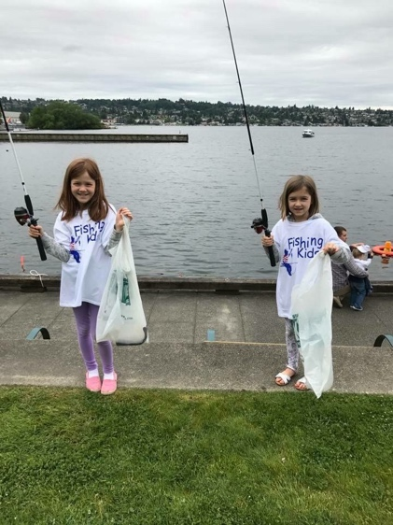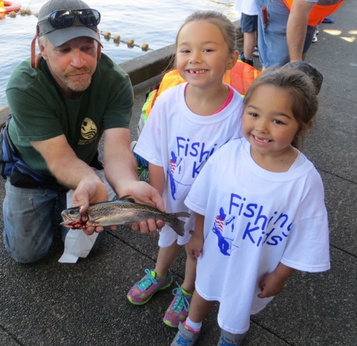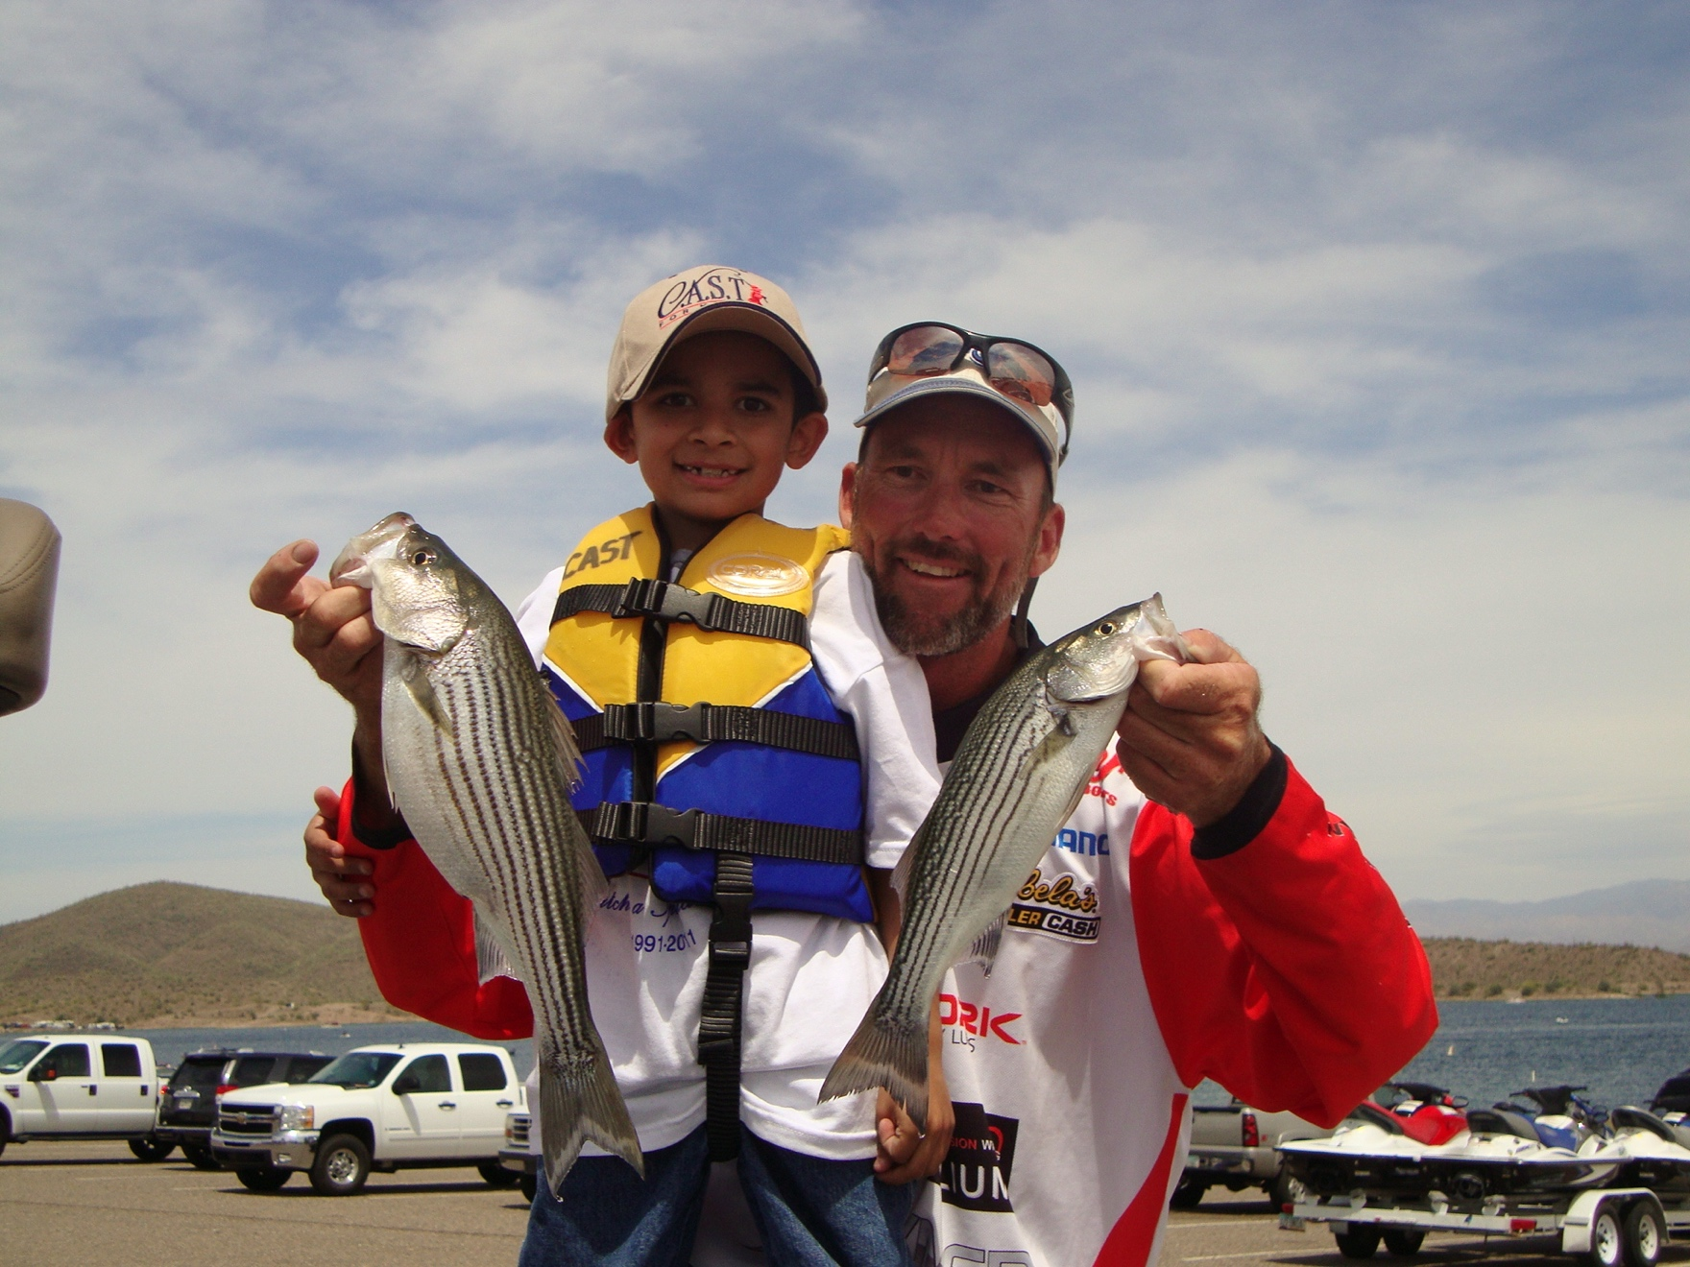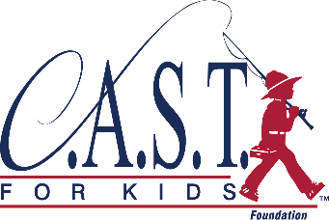

Fishing Kids Green Lake

Saturday, May 12, 2018 | 8:00 AM – 2:00 PM

Volunteer with C.A.S.T. for Kids today!

**Get more kids fishing,**

**More often!**

VOLUNTEERS help us make a **SPLASH**

**www.castforkids.org**

* Fishing Volunteers needed!  
  **40 experienced anglers** to help bait hook, help children cast, teach outdoor stewardship and remove fish from hook. Also need fish cleaning volunteers!
* On-Shore Volunteers  
  15 volunteers needed to assist with all aspects of event setup and facilitation such as registration and handing out gear

**Pre-registration required at http://castforkids.org/event/greenlake/**

If you have questions, please contact:  
Kristen Phillips  
kristen@castforkids.org  
(425)251-3202

May 12, 2018