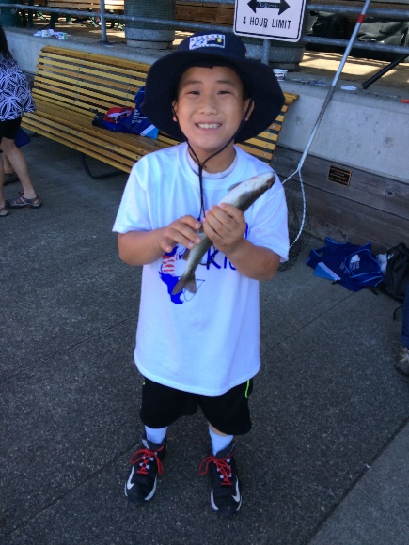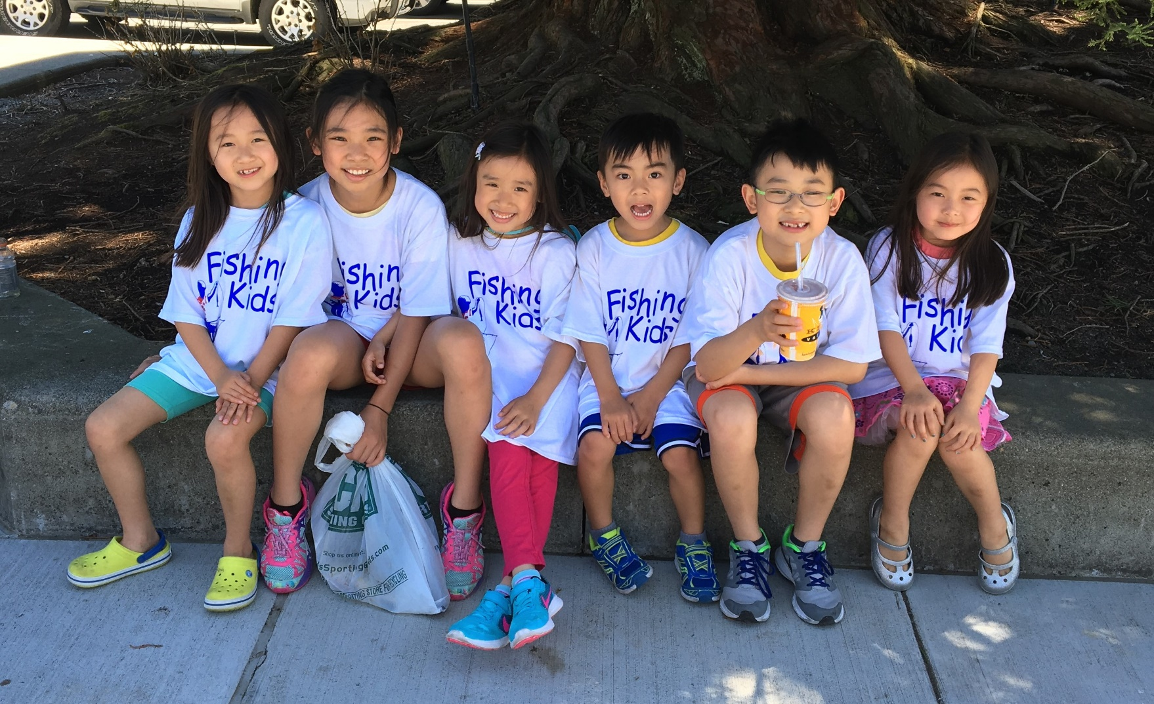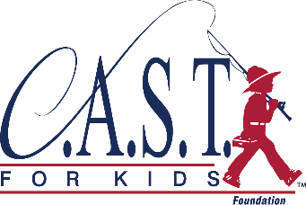

Available Sessions:

#3- 12:00pm

#4- 1:00pm

Registration provided by City of Seattle

Phone number: 425-251-3202

**Register now!**

Get more kids fishing,

More often!

* Fishing GEAR FUN-PACK!  
  Includes rod & reel, event t-shirt and goody bag to bring home!
* WHO?  
  Participantsmust pre-register and should be 5-14 years of age.
* REGISTRATION  
  **Pre-registration required at**  **http://castforkids.org/event/greenlake**

If you have questions, please contact:  
Kristen Phillips  
(425) 251-3202

Make a **SPLASH**

Green Lake Fishing Kids

Saturday, May 12, 2018 | Sessions from 9 AM – 1 PM

*Space is limited—sign up today!*

*Cost: $25 per child!*

**www.castforkids.org**

May 12, 2018